### American International University- Bangladesh

**Department of Electrical and Electronic Engineering**

EEE 4103: Microprocessor and Embedded Systems Laboratory

**Title:** Familiarization with an STM32, the study of blink test and implementation of a light-controlling system using microcontrollers.

**Introduction:**

The objective of this experiment is to get familiarized with Microcontroller.

▪ Learning to make the LED blink using ST32.

* Implementation of a light control system using STM32.

**Theory and Methodology:** STM32CubeIDE is an advanced C/C++ development platform with peripheral configuration, code generation, code compilation, and debug features for STM32 microcontrollers and microprocessors. STM32CubeIDE includes build and stack analyzers that provide the user with useful information about project status and memory requirements.STM32CubeIDE also includes standard and advanced debugging features including views of CPU core registers, memories, and peripheral registers, as well as a live variable watch, Serial Wire Viewer interface, or fault analyzer.

**Overview of STM32 Nucleo-F401RE Board:**

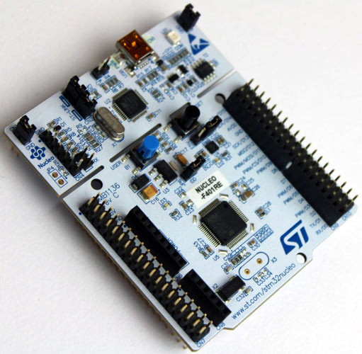

**Pin Configuration:**

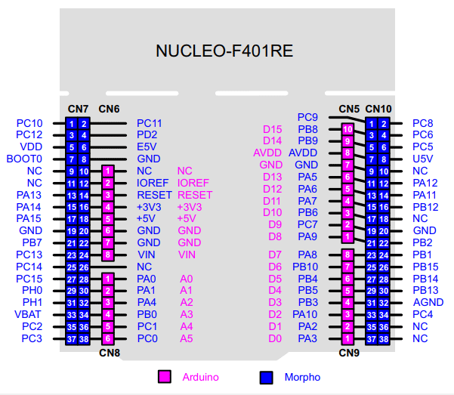

**Pin configuration from STM32Cube IDE:**

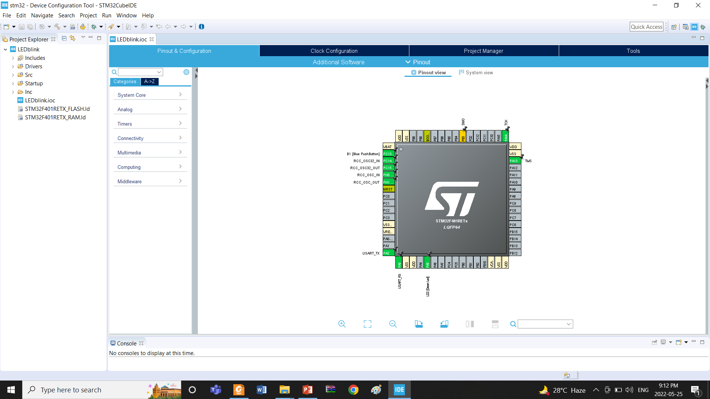

**Apparatus:**

|  |
| --- |
| 1) STM32 Cube IDE (1.0.1 or any recent version) |
| 2) STM32 Cube IDE board |
| 3) LED lights (RED, GREEN, or YELLOW) and three 200 ohms resistors and jumper wires |
|  | |

**Experimental Procedure:**

The main task of our lab is to understand and implement a light control system after understanding to blink a LED light. Make the circuits first using the following connection system between all the elements. Then plug in the STM32 Nucleo board to the PC.

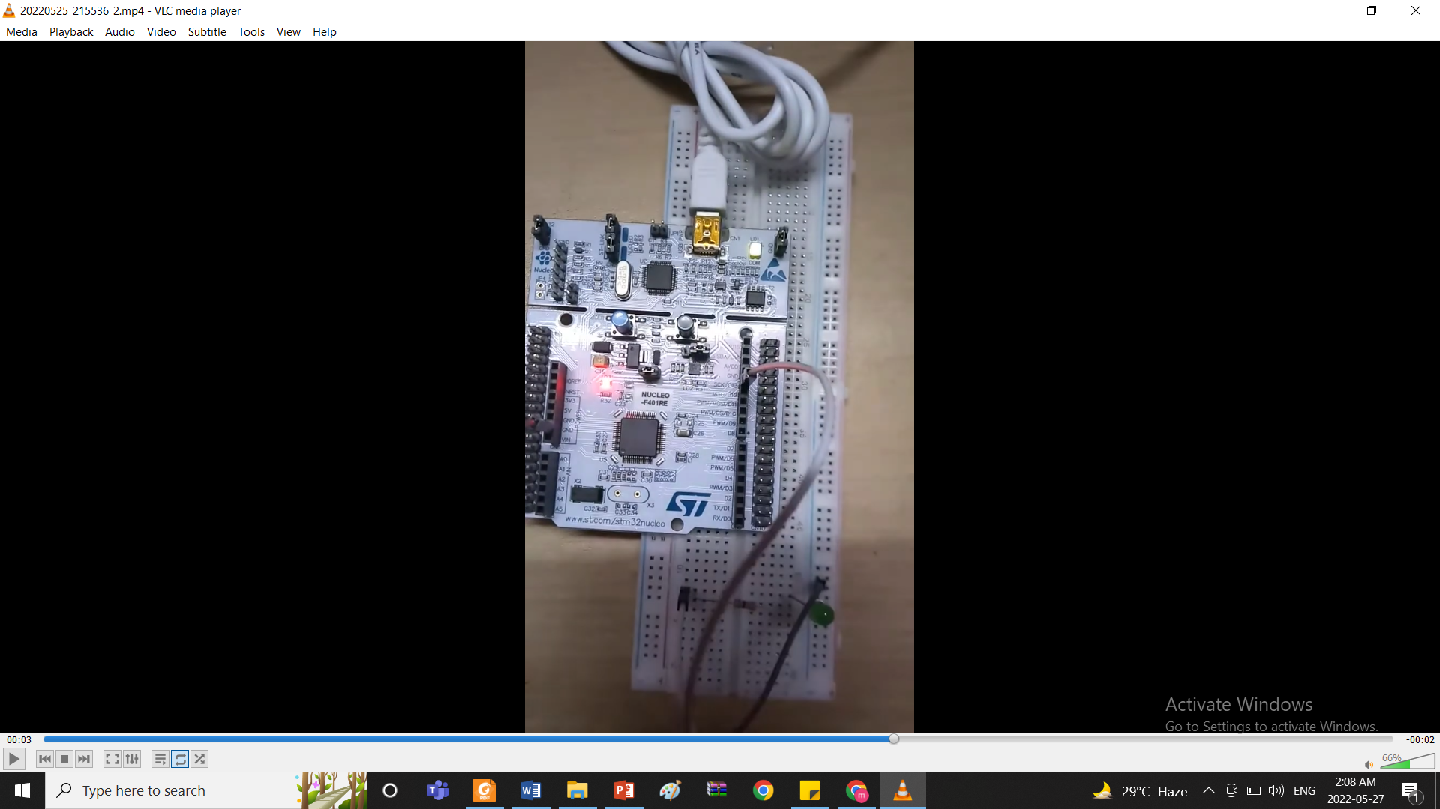 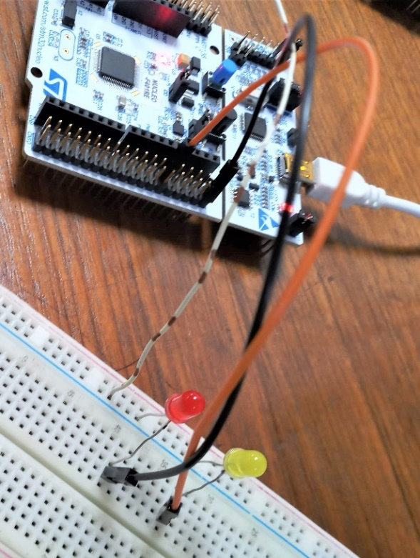

**Using STM32Cube IDE to write code for a simple Blink program first:**

1. Open the STM32Cube IDE and in the first while loop write the program as follows:

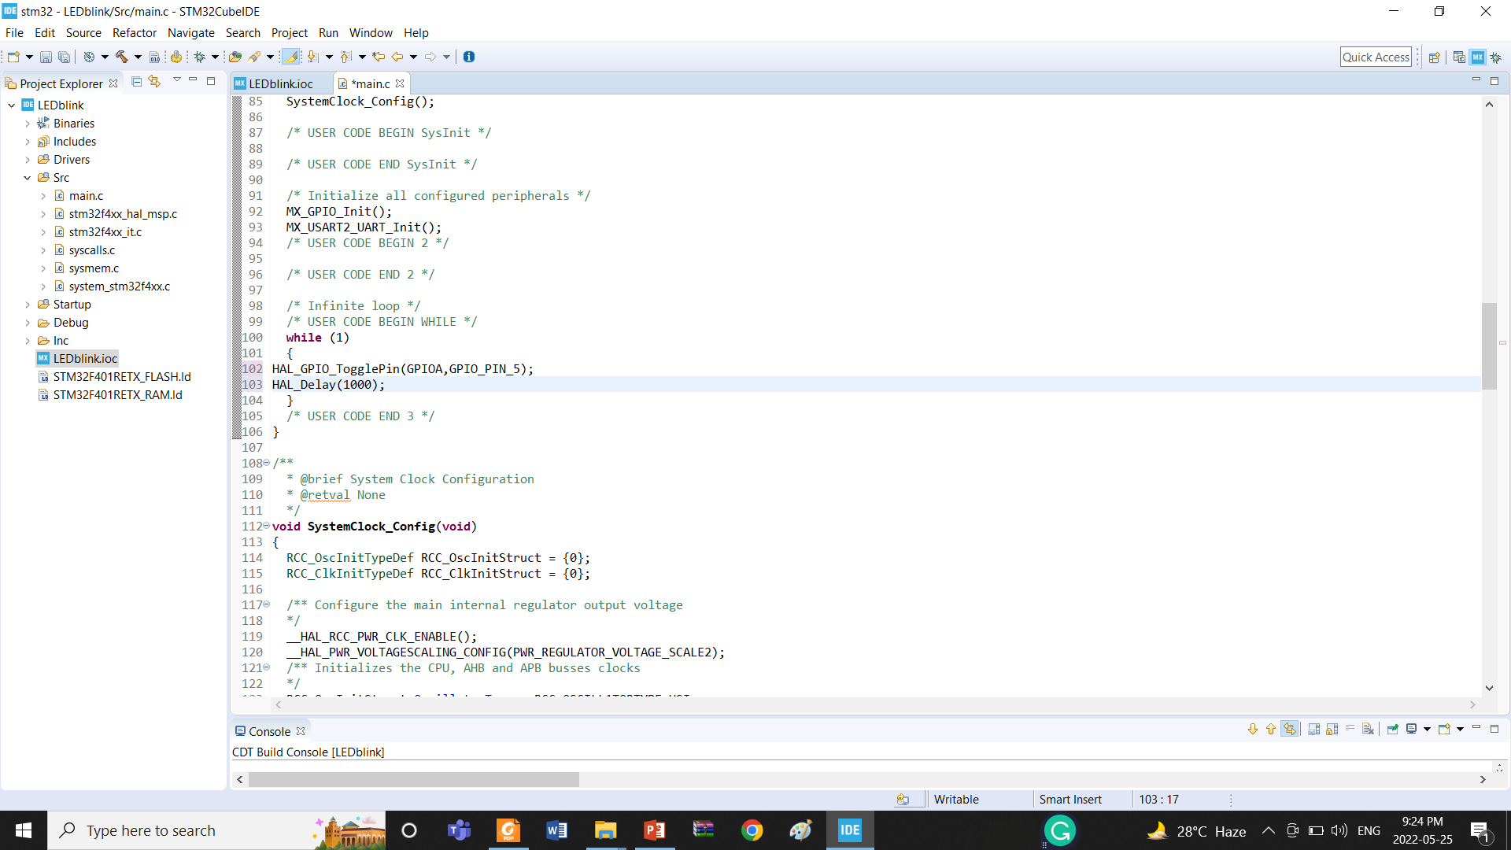

1. Next save the project file then build the project.

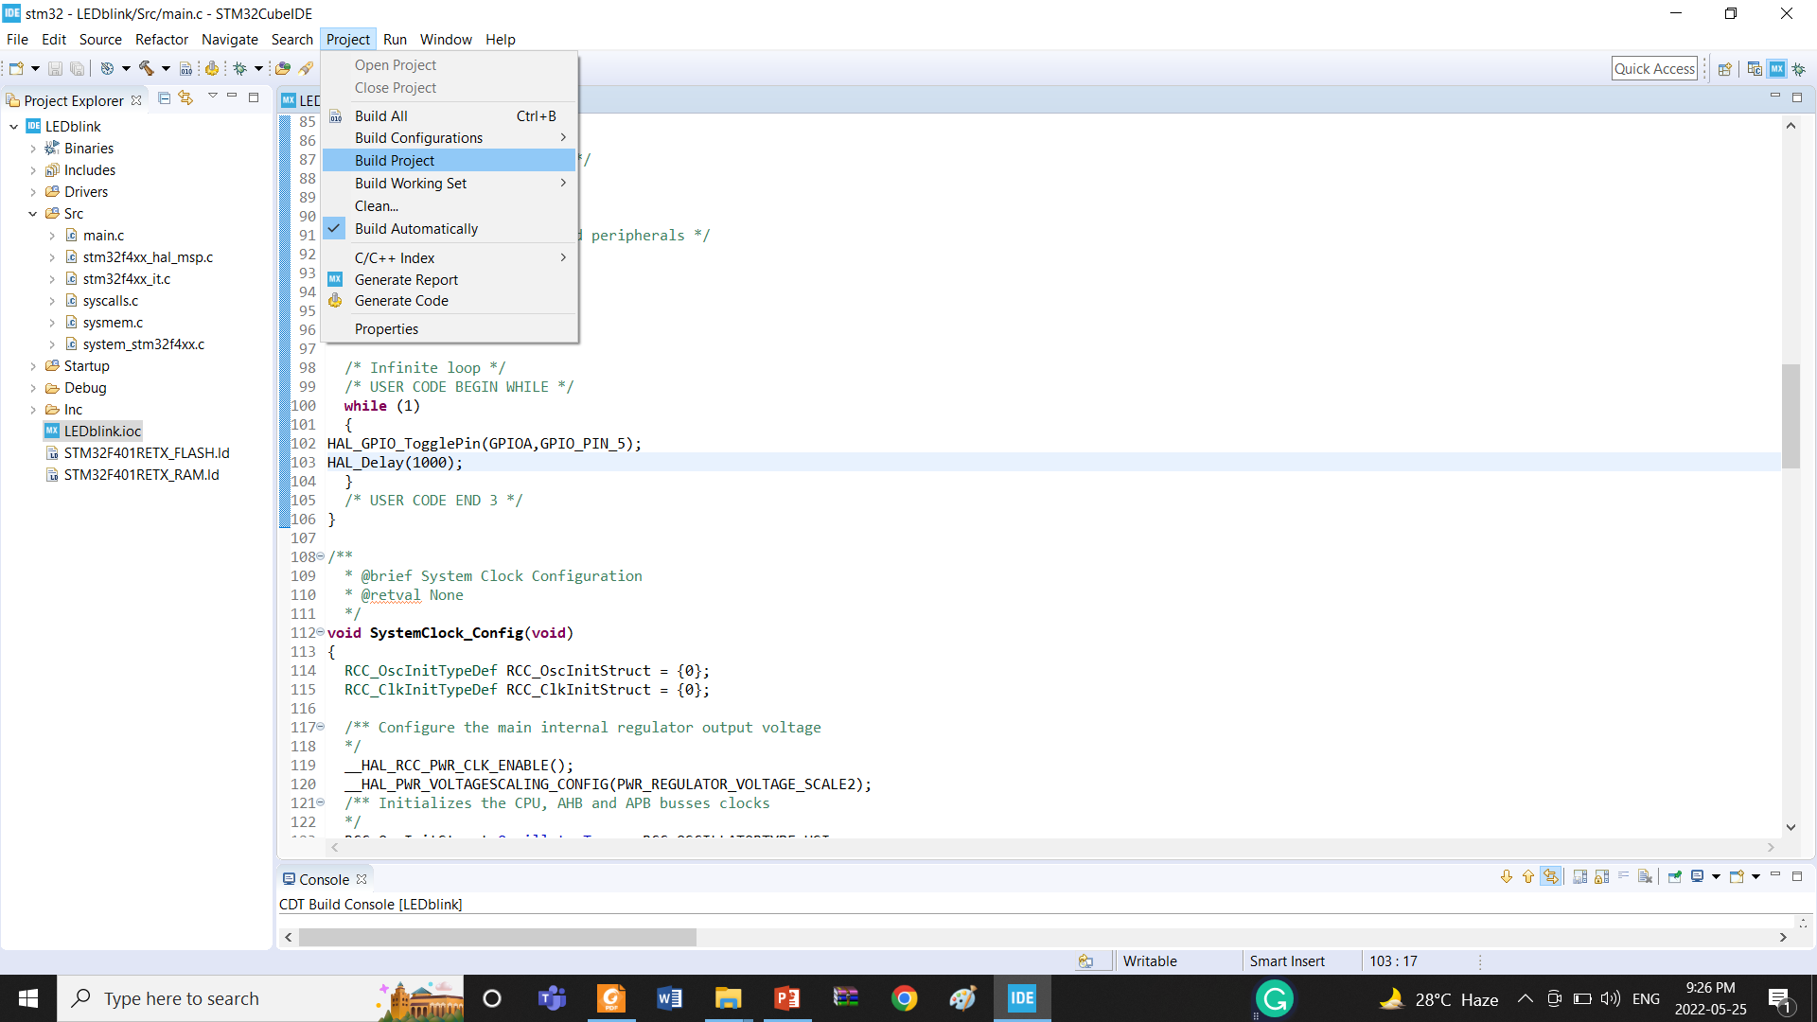

1. Next, run the program to debug as STM32 MCU C/C++ Application.

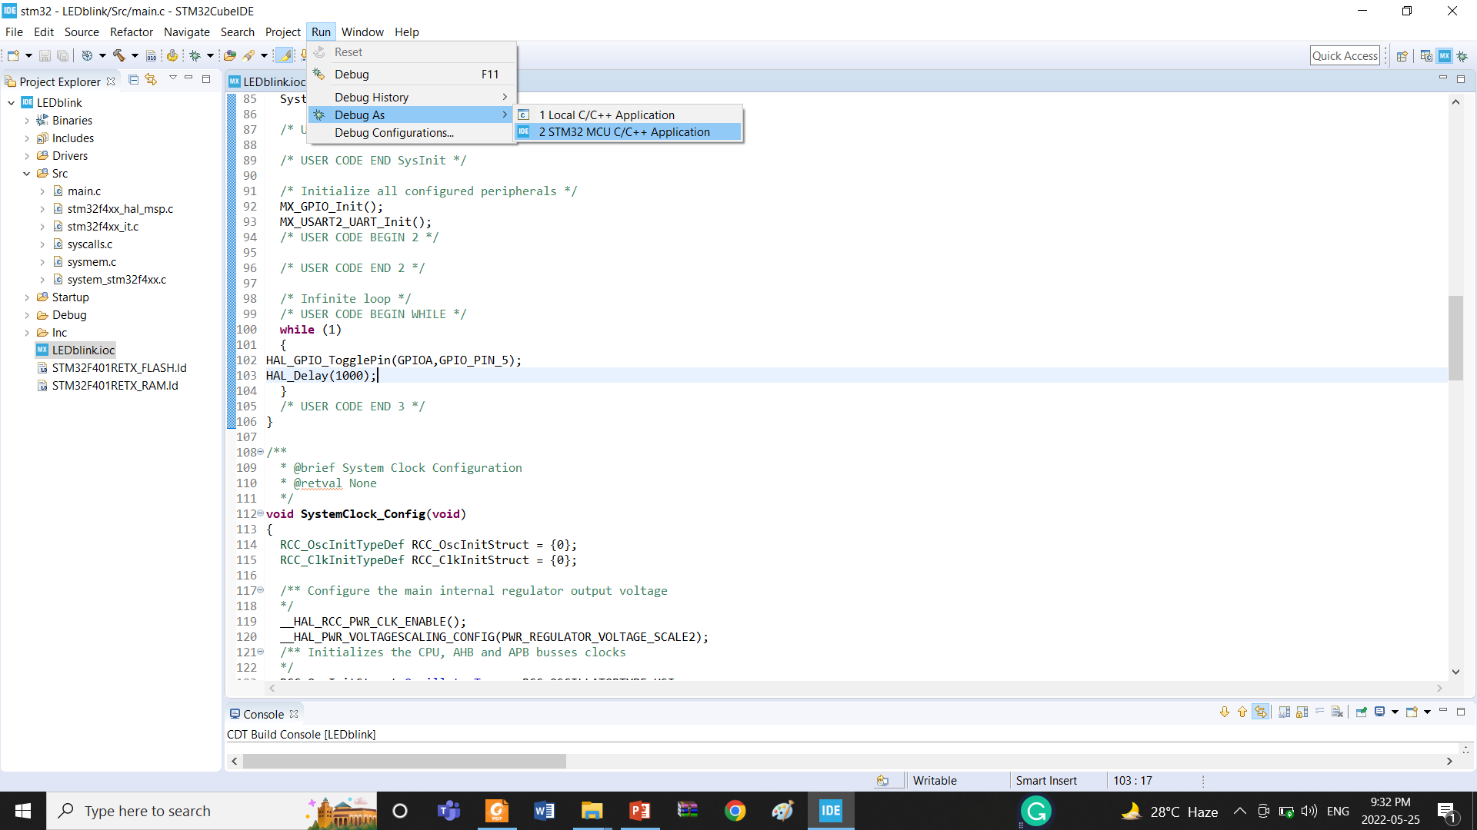

1. Select the resume option to see the board showing results to blink the LED lights.

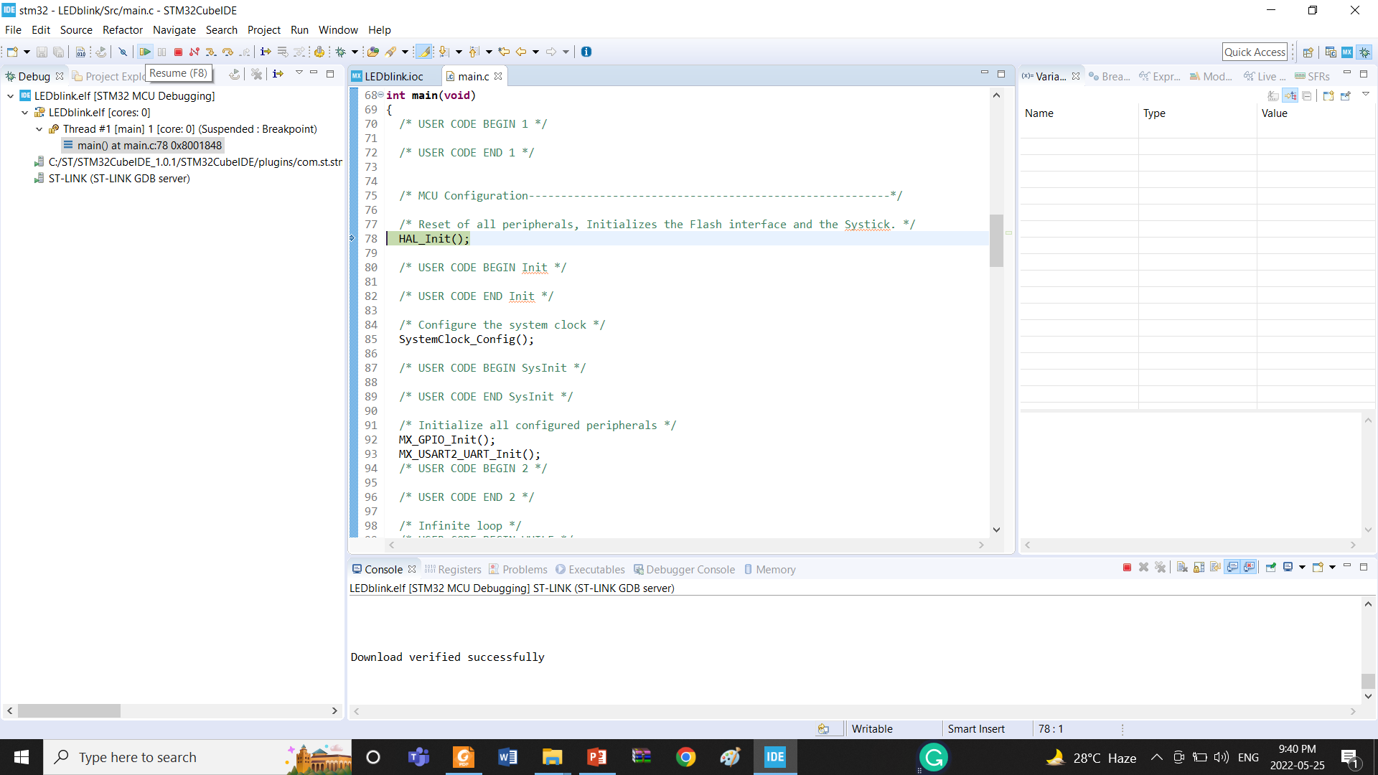

**Try to rewrite the code again for the two LED lights**

**Questions for report writing:**

1. Include all codes and scripts into the lab report following the writing template mentioned in appendix A of Laboratory Sheet Experiment 2.
2. Include the proteus simulation of the blink program and light control system. you can learn the simulation from the following link:

<https://www.youtube.com/watch?v=MDsoLQicdAk>

1. Design a simulation for a traffic system using the Proteus simulation tool and STM32Cube IDE.

**Reference(s):**

* <https://www.st.com/en/evaluation-tools/nucleo-f401re.html> for STM32F401RE,datasheet
* [www.st.com](http://www.st.com/)
* <https://www.st.com/resource/en/user_manual/dm00105879-description-of-stm32f4-hal-and-ll-drivers-stmicroelectronics.pdf>
* [www.st.com/en/development-tools/stm32cubeide.html](http://www.st.com/en/development-tools/stm32cubeide.html)